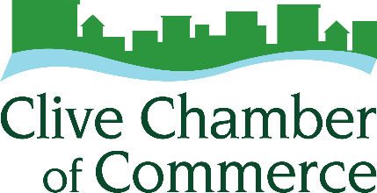
2025 Chamber Champion Nomination Form
This award is given to recognize one member of the Clive Chamber of Commerce who exhibits outstanding stewardship, active engagement and is a champion of the Clive business community.

Requirements:
Nominee must be an active member of one of the following Chamber Committees:
- Ambassador Committee
- Communications & Marketing Committee
- DEI Committee
- Government Affairs Committee
- Membership Committee
Deadline: Thursday, January 15, 2026 ▪ Forms received after that will not be considered.

Mail or E-mail completed form to:
Clive Chamber of Commerce, 1900 NW 114th Street, Clive, IA 50325 ▪ info@clivechamber.org

Past Chamber Champion Winners:
2019 – Ben Chamber, Middendorf Insurance Associates
2020 – Chuck Jones, Charles Jones CPA
2021 – Mary Anne Kennedy, Primary Source
2022 – Susan Dunn
2023 – Lu Anne Gafford, Life 107.1
2024 – Cinnamon Rost, 1809 Design

Your Name, Email and Phone Number: Click or tap here to enter text.

Nominee for Chamber Champion: Click or tap here to enter text.

Please include a statement to support your belief that the nominee deserves to be recognized as Clive Chamber Champion of the Year.
Click or tap here to enter text.

