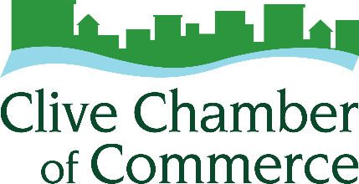
2025 Business of the Year Nomination Form
This award is given to recognize the contribution of a Clive Chamber of Commerce member that contributes to the economic growth and quality of life in Clive and whose practices and professional conduct contribute to a sense of cooperation within the entire business community. Some of the specific criteria that could be considered for this award include: a successful marketing or business strategy; growth; community involvement; exceptional customer service.

Requirement:
Nominee must be Clive Chamber of Commerce member in good standing.
Deadline: Thursday, January 15, 2026 ▪ Forms received after that will not be considered.

Mail or E-mail completed form to:
Clive Chamber of Commerce, 1900 NW 114th Street, Clive, IA 50325 ▪ info@clivechamber.org

Past Business of the Year Winners:
2008 - Primary Source
2009 - Bankers Trust
2010 - Shive-Hattery
2011 - Nobbies Party Superstore
2012 - Woodlands Creek Active Retirement Community
2013 - Middendorf Insurance Associates
2014 - Fareway Stores
2015 – NCMIC
2016 – McClure Engineering Company
2017 – TBL Print
2018 – ServiceMaster by Rice
2019 – Nebraska Furniture Mart
2020 – 5 Borough Bagels
2021 – MercyOne Health & Fitness Center
2022 – Nothing Bundt Cakes
2023 – Big Brothers Big Sisters of Central Iowa
2024 – Walter Roofing

Your Name, Email, and Phone Number: Click or tap here to enter text.

Nominee for Business of the Year: Click or tap here to enter text.

Please include a statement to support your belief that the nominee deserves to be recognized as Clive Chamber Business of the Year.
Click or tap here to enter text.

